1. Extract Provided ZIP file in to [USER DEFINED] location
2. Create database table, procedure and master data. Script provided inside folder “SQL”
   1. Bill2Pay_K1099_DB.sql
3. Open IIS Console

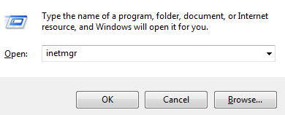

Note: User require extra privileges to open IIS Console

1. Verify Application Pool

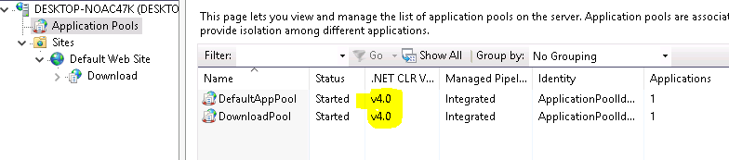

Verify .Net 4.0 framer is installed, and IIS Application pool is configured with it.

1. Create IIS Application

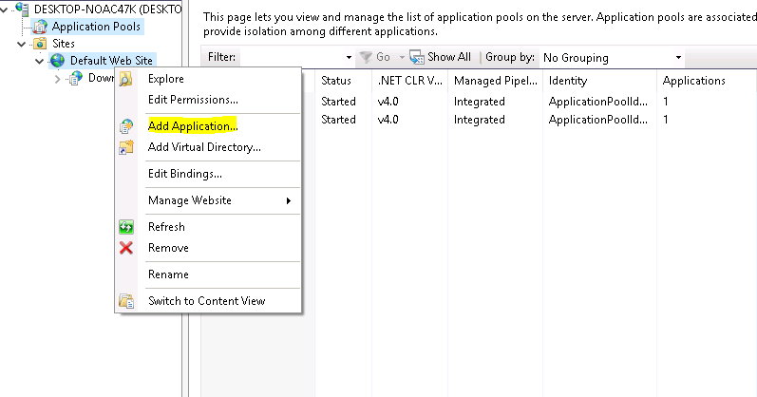

Right Click over Default Web Site, and “Add Application”

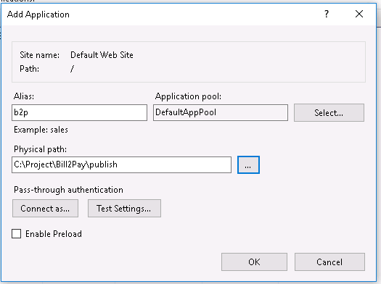

Provide necessary information.

1. Alias: [USER DEFINED NAME]
2. Application Pool: 4.0 Integrated
3. Physical File Path: Physical folder location of the application.
4. Verify DB Connection

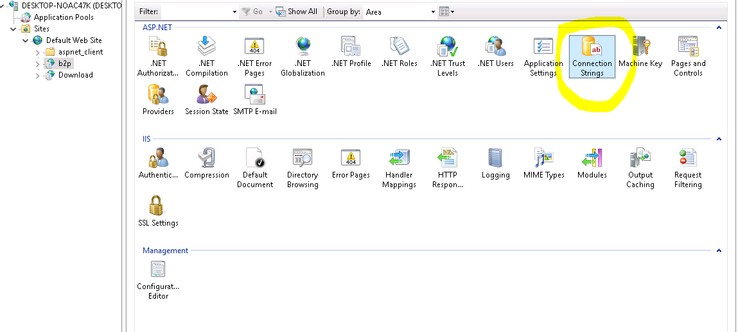

1. Change DB Connection accordingly

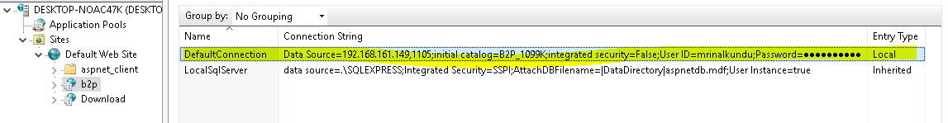

1. Enable Form Authentication

